Brief Profile

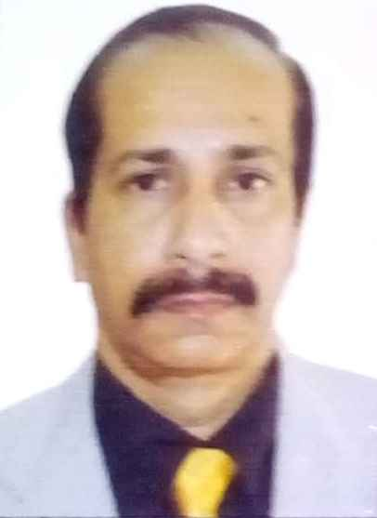
Name: - Prof. (Dr.) Soumitra Sen, Dean, Royal School of Hotel Management, Royal School of Travel & Tourism Management and Royal School of Aviation & Flying.
Retired as HOD in Institute of Hotel Management, Guwahati under Ministry of Tourism, Govt of India and Centre Coordinator of IGNOU for their B. Sc. in Hospitality and Hotel Administration Course.
National Level Recognised Trainer by Department of Personnel & Training under PMO, Govt. of India for their flagship Trained the Trainer Programs DTS and DoT.
Educational Qualification: - Graduate from Calcutta University, Maters from Madurai Kamraj University and Ph. D. from KKHSOU.
Technical Qualification: - Graduate in Hotel Management, Catering Technology & Applied Nutrition from IHM, Guwahati.
Honorary Advisor to:
i) Dibrugargh University, Assam for their UG program of Hotel Management,
ii) Krishna Kanta Handique State Open University {KKHSOU}, Assam,
iii) The Global Open University, Nagaland for their Tourism & Hospitality Courses,
iv) Furkuting College for their content developer of B.Voc course in Hotel Management under Dibrugarh University,
v) Assam Institute Management for their erstwhile Travel & Tourism Management course as visiting Professor.

Academic Experience: - 38 years,
Research Publications: - 11 (05 Internationals and 06 National Levels),
Chairing Seminar Technical Sessions: - 01 (International Seminar).
Guide: Currently 07 Research Scholars of RGU pursuing their thesis under his guide ship.

